**Follow-along guide for Splunk sign-up**

***Note:*** *The following reading is an optional supplement to the following course item,* [*Activity: Perform a query with Splunk*](https://www.coursera.org/learn/detection-and-response/quiz/QGT1e/activity-perform-a-query-with-splunk)*.* ***Both this reading and the following activity are optional and will not affect your completion of the course.*** *You may choose to skip this reading and/or the activity for any reason, and continue progressing through the remainder of the course.*

This reading includes detailed instructions for getting started with the following course item, [***Activity: Perform a query with Splunk***](https://www.coursera.org/learn/detection-and-response/quiz/QGT1e/activity-perform-a-query-with-splunk)**.** Use this reading for step-by-step instructions on how to create a Splunk Cloud account, activate a Splunk Cloud free trial, and upload data to a Splunk Cloud instance.

The following guide identifies parts of the video that may require adjustment. This reference guide can also serve as a usability reminder when using Splunk Cloud in the future.

**Instructions**

**Part 1 - Create a Splunk Cloud account**

1. Go to the [Splunk Cloud Platform Trial](https://www.splunk.com/en_us/download/splunk-cloud.html) page.
2. Fill in the fields in the **Start Your Cloud Platform Trial** sign-up form.
3. Click **Create Your Account**.

**Part 2 - Verify your email**

1. Check the inbox for the email address that you used to sign up for the Splunk account. Find the verification email from Splunk with the subject line **Confirm your email address**.

2. Open the email and click the **Verify Your Email** button.

***Note****: Check your spam folder if you didn't receive the verification email.*

**Part 3 - Activate a Splunk Cloud trial**

After clicking the **Verify Your Email** button, you'll be redirected to the Splunk Cloud Trial page.

***Note****: You can activate one Splunk Cloud trial instance at a time, and you can use a maximum of three trials per Splunk account. The Splunk Cloud free trial expires after 14 days, so  you may want to complete this activity before the free trial expires.*

***Note:*** *Alternatively, you can also access the Splunk Cloud Trial page by visiting* [*Splunk Cloud Platform Trial*](https://www.splunk.com/en_us/download/splunk-cloud.html) *and logging into your account, then clicking* ***Start Trial****.*

1. Click the **Start Trial** button.

2. Check your inbox for an email from Team Splunk with the subject line **Welcome to Splunk Cloud Platform!**

3. Open the email to access your Splunk Cloud login information.

4. Click the link beside **URL** to access the Splunk Cloud Platform.

5. Enter the username and password credentials that were included in the email.

6. You will be prompted to change the password of the Splunk Cloud Platform account. Enter a new password and click **Save Password**.

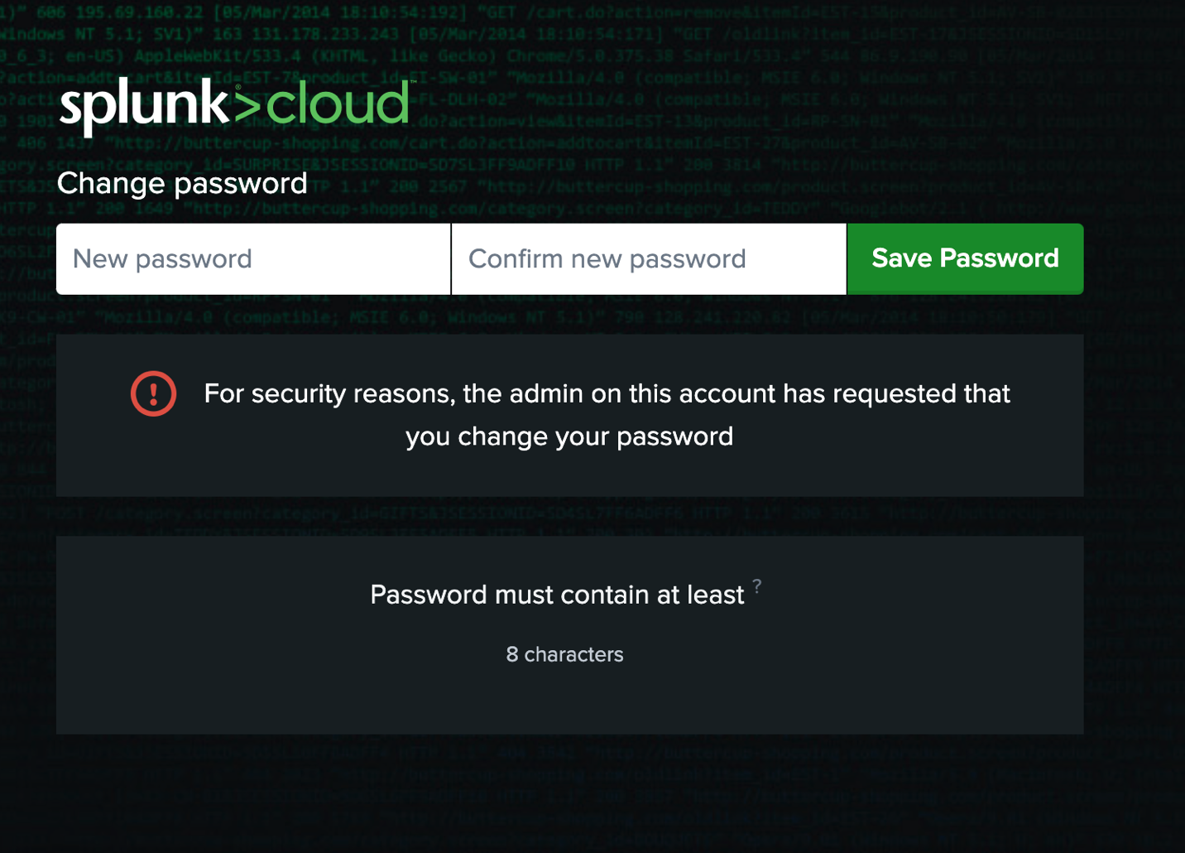

7. Check the box next to **I accept these terms** and click **Ok**.

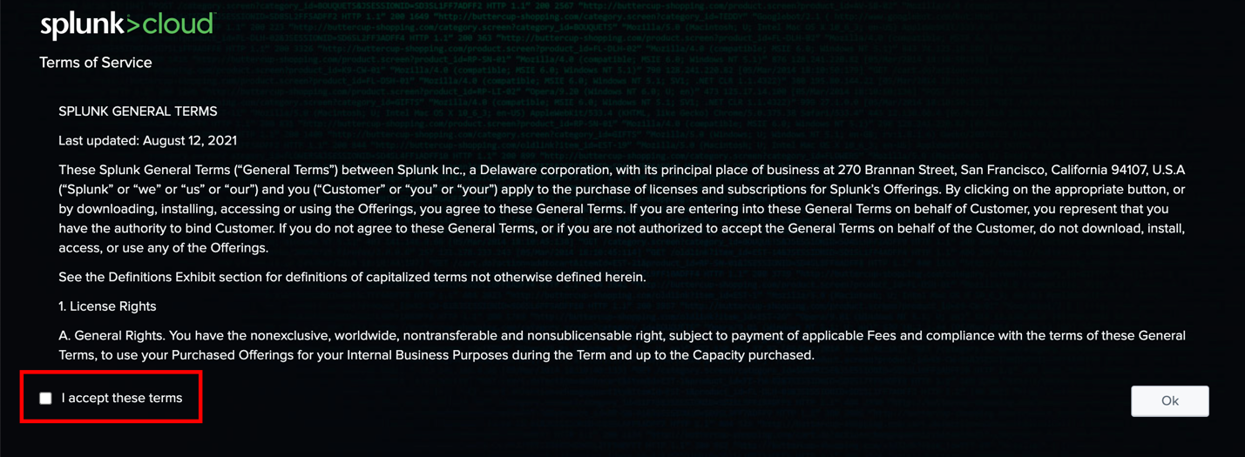

**Part 4 - Download and upload Splunk data**

After you've accepted the Terms of Service, you'll automatically be redirected to the Splunk Home dashboard.

1. Go to [Activity: Perform a query with Splunk](https://www.coursera.org/learn/detection-and-response/quiz/QGT1e/activity-perform-a-query-with-splunk).

2. Go to **Step 1: Access supporting materials**.

3. Beside **Link to supporting materials** click [**tutorialdata.zip**](https://drive.google.com/file/d/1nDz_DZB4ADbD4tvaDa54_l1FoT_jtVy4/view?usp=share_link).

4. Click the **download icon** to download the zip file.

5. Go to the Splunk Home dashboard.

6. On the Splunk bar, click **Settings** and then click **Add Data**.

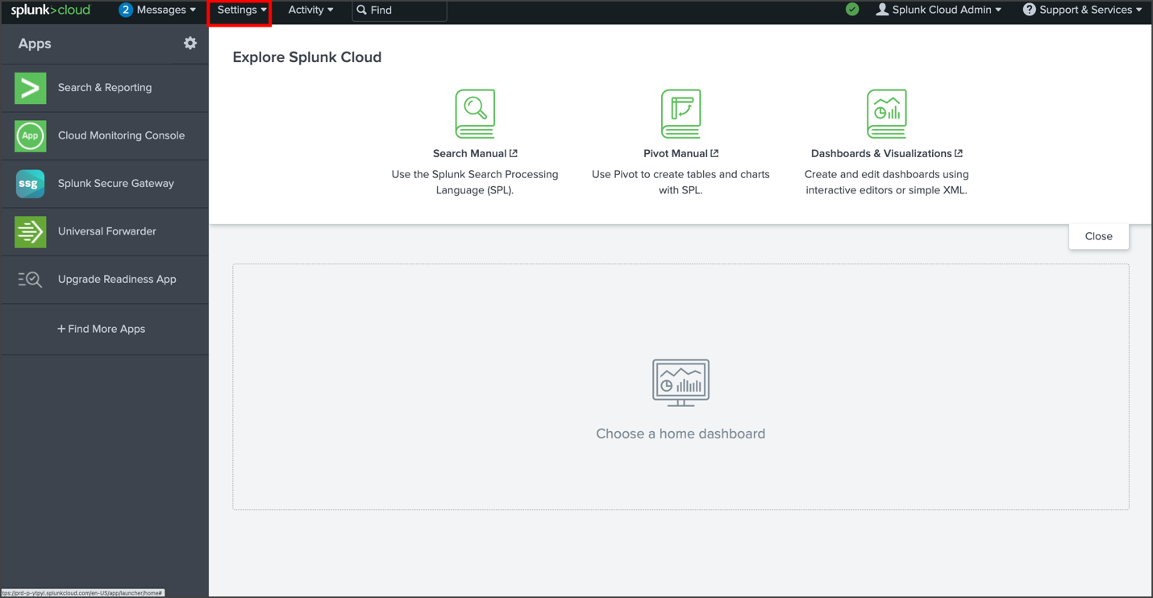

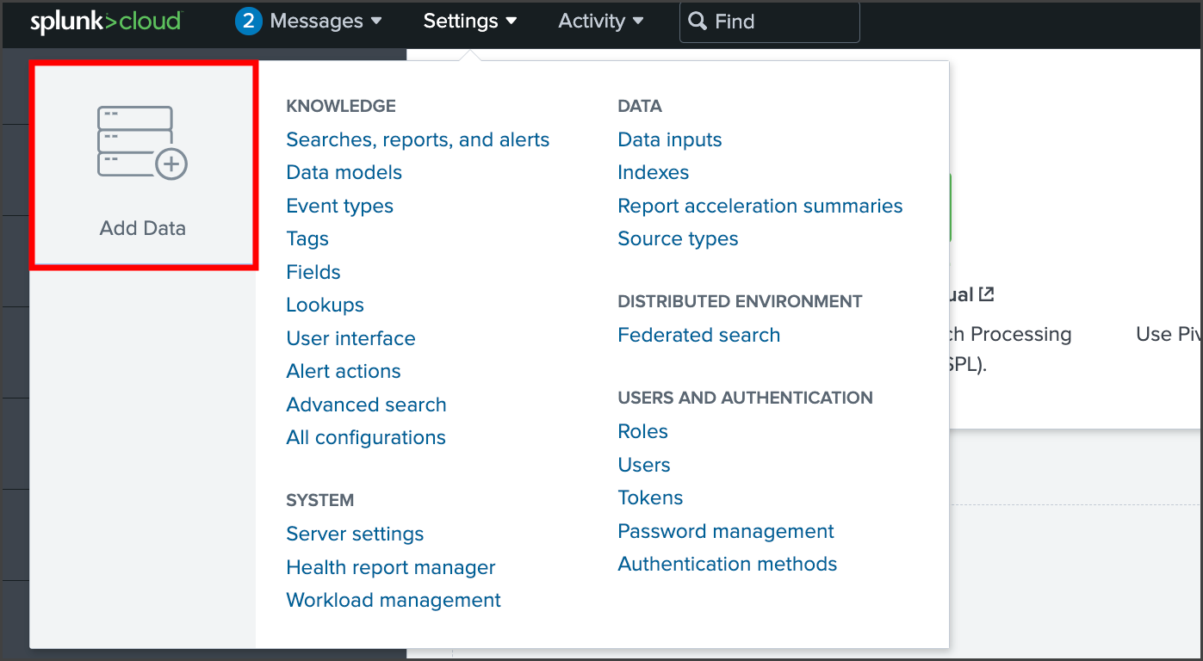

7. Click **Upload**.

8. Click **Select File** to upload the **tutorialdata.zip** file. Alternatively, you can also drag and drop your file in the **Drop your data file here** box.

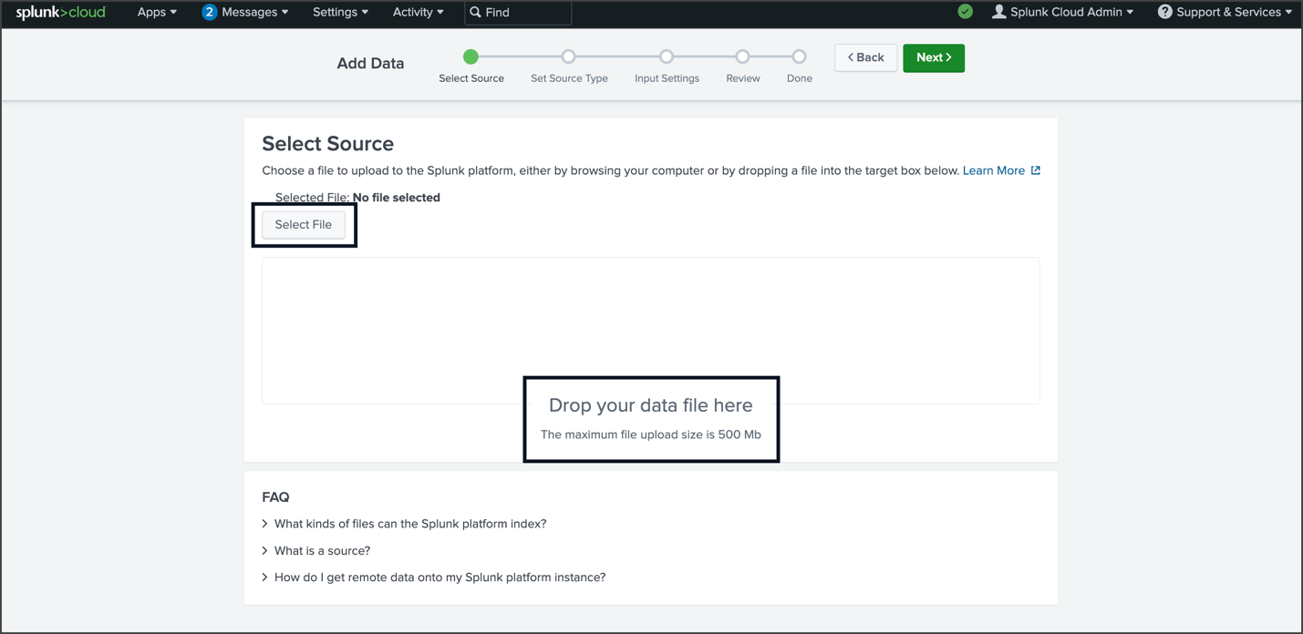

9. Once the file is uploaded, click **Next** to continue to **Input Settings**.

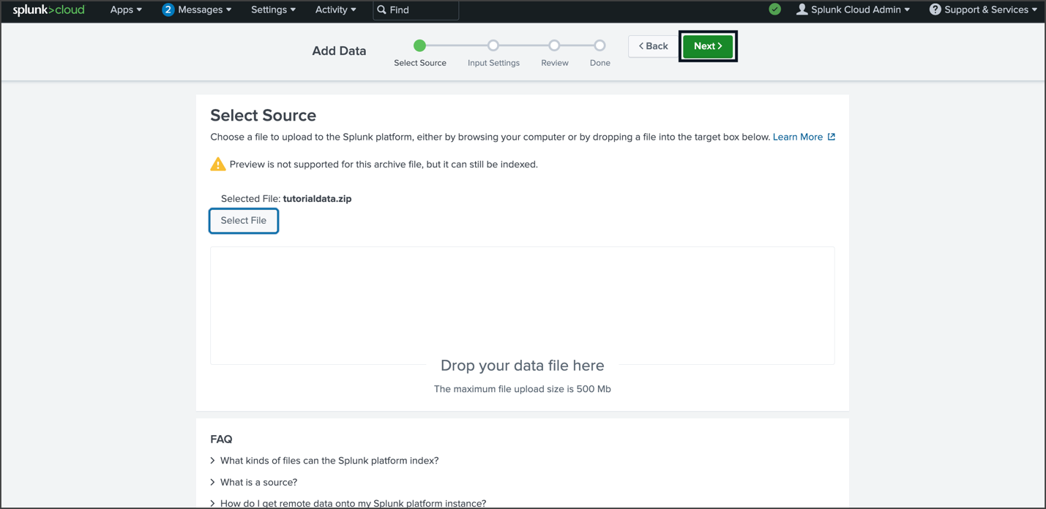

10. By the **Host** section, select **Segment** **in** **path** and enter **1** as the segment number.

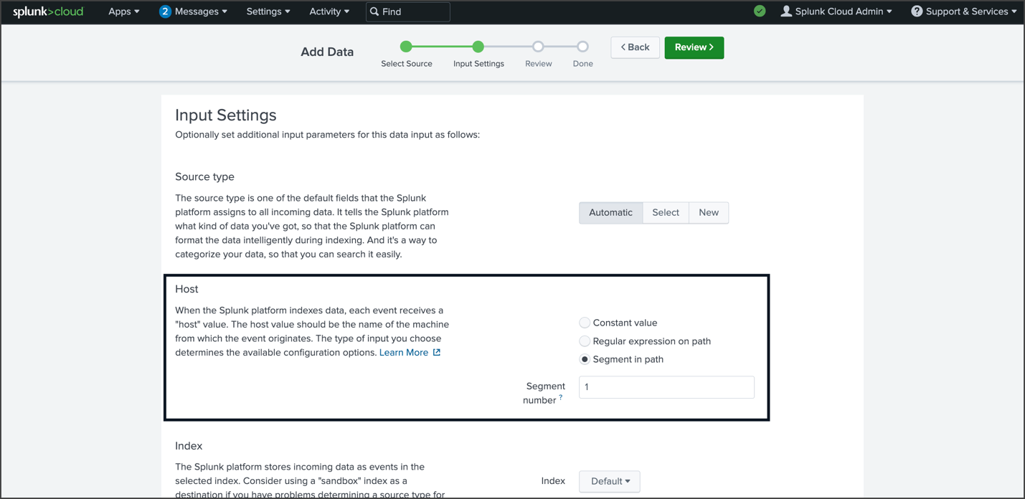

11. Click **Review** and check the details of the upload before you submit. The details should be as follows:

* Input Type: Uploaded File
* File Name: tutorialdata.zip
* Source Type: Automatic
* Host: Source path segment number: 1
* Index: Default

12. After you've verified that the details are correct, click **Submit**.

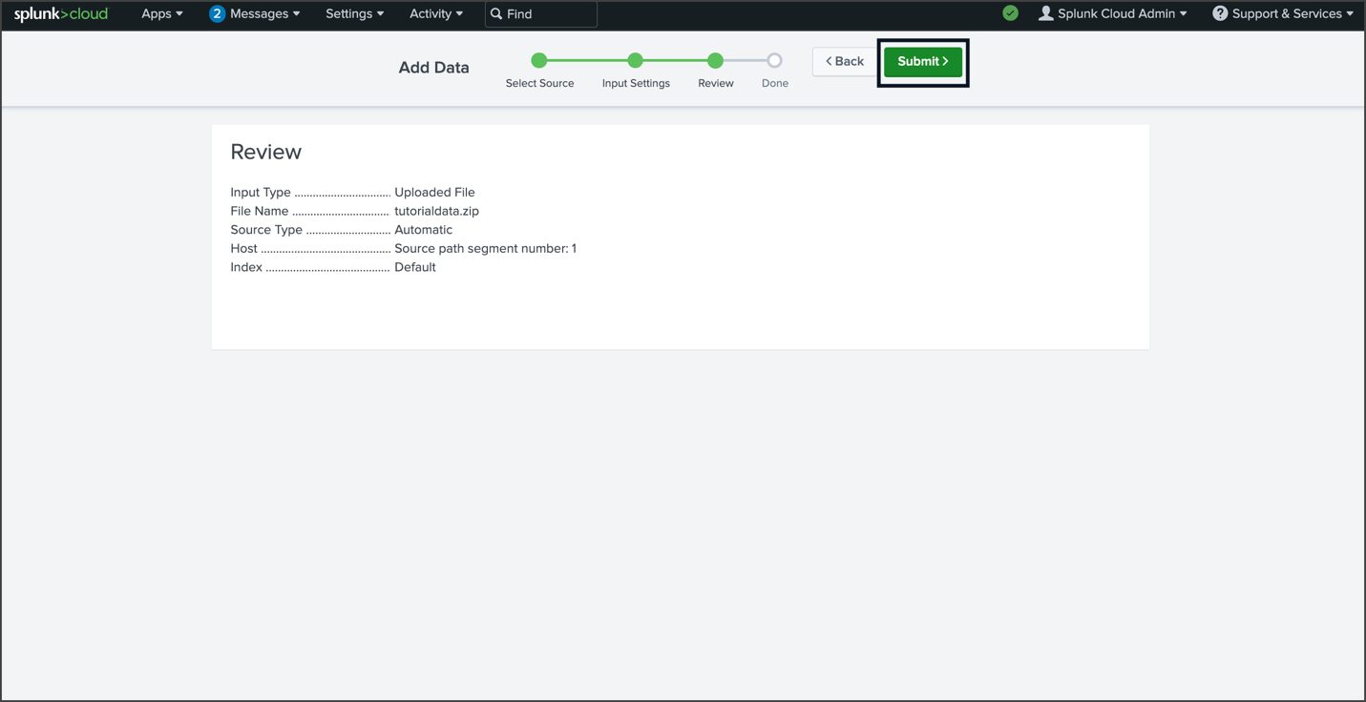

13. Once Splunk has ingested the data, you will receive a confirmation message stating that the file has been uploaded successfully.

14. Click the **Splunk** **Cloud** logo to return to the home page.

**You're done!** Once your Splunk Cloud account is set up, you can begin the next course item, [Activity: Perform a query with Splunk](https://www.coursera.org/learn/detection-and-response/quiz/QGT1e/activity-perform-a-query-with-splunk).

***Need additional help?*** *If you are experiencing any issues with your Splunk Cloud account, please contact* [*Splunk's Help Center*](https://www.splunk.com/en_us/about-splunk/contact-us.html)*.* ***Remember, the following course item,*** [***Activity: Perform a query with Splunk***](https://www.coursera.org/learn/detection-and-response/quiz/QGT1e/activity-perform-a-query-with-splunk)***, is optional and will not affect your completion of the course.*** *If you are not able to create and set up a Splunk Cloud account, you can skip the activity.*